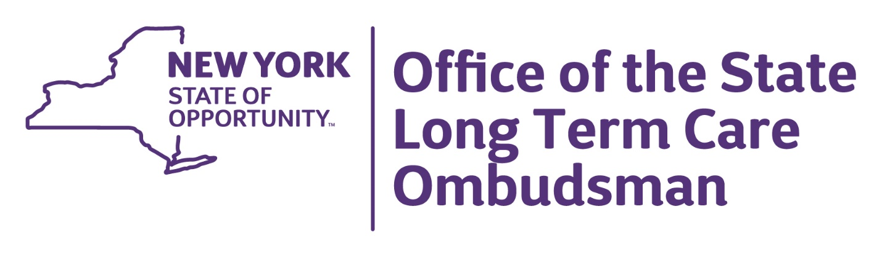

Volunteer Position Description
Certified Ombudsmen are resident advocates who identify, investigate, and resolve complaints in order to protect the rights, dignity, and safety of individuals who live in nursing homes, adult care facilities, and assisted living facilities. Certified Ombudsman volunteers are appointed by the State Long-Term Care Ombudsman and report directly to the Coordinator of their assigned region.
Duties:
• Visit with residents and work to identify complaints and concerns.
• Monitor resident care, staffing and building conditions.
• Investigate complaints.
• Work with facility staff to correct problems, using a continuum of problem resolution and
advocacy skills.
• Report all apparent cases of abuse to the regional Program Coordinator and Long-Term Care Ombudsman Program (LTCOP) State Office as required by program policy and procedure.
• Submit required documentation at least monthly.
• Maintain ongoing communication with regional program staff.
• Promote respect and rapport between residents, facility staff and Ombudsman program.
• Inform and educate residents, families, and facility staff about resident rights.
• Maintain confidentiality as required by law.
Qualifications and Skills:
• 18 years of age or older and must pass a background check.
• Strong observation, communication, and problem- solving skills.
• Dependable and reliable.
• Adequate transportation to visit facilities.
Training:
• 36 hours of initial certification training including classroom, homework, and facility visits.
• 18 hours of continuing education annually to maintain certification.
Time Commitment:
• Minimum of 10 hours per month, including facility visits, monthly training meetings, and completing paperwork.
• Nursing homes, adult care facilities, and assisted living facilities are visited weekly.
Benefits:
• Improve the quality of care for residents in long-term care in your community.
• Ability to make a personal, direct, immediate positive impact for others.
• Develop knowledge and expertise on navigating long-term care systems.
• Free training, support from regional program staff.
• Gain valuable work or career experience.
• Increase or develop public speaking, advocacy, and conflict resolution skills.
• Annual recognition and training events, monthly continuing education opportunities.

