Date: January 11, 2016
Supersedes: May 7, 2015
Reviewed: December, 2015
Author/Administrator: Help Desk

FTP USER GUIDE
Release Version: 1.0.0

Dec, 2015

NY State Office for Aging (NYSOFA)

FTP Login:

URL: https://datax.aging.ny.gov - Login to the given portal and provide the username and password.

The Pre-Login Screen: Shown below is the pre-login screen where user can enter their login credentials or ‘forgot username’.
- Enter the username (eg. ofa_user)
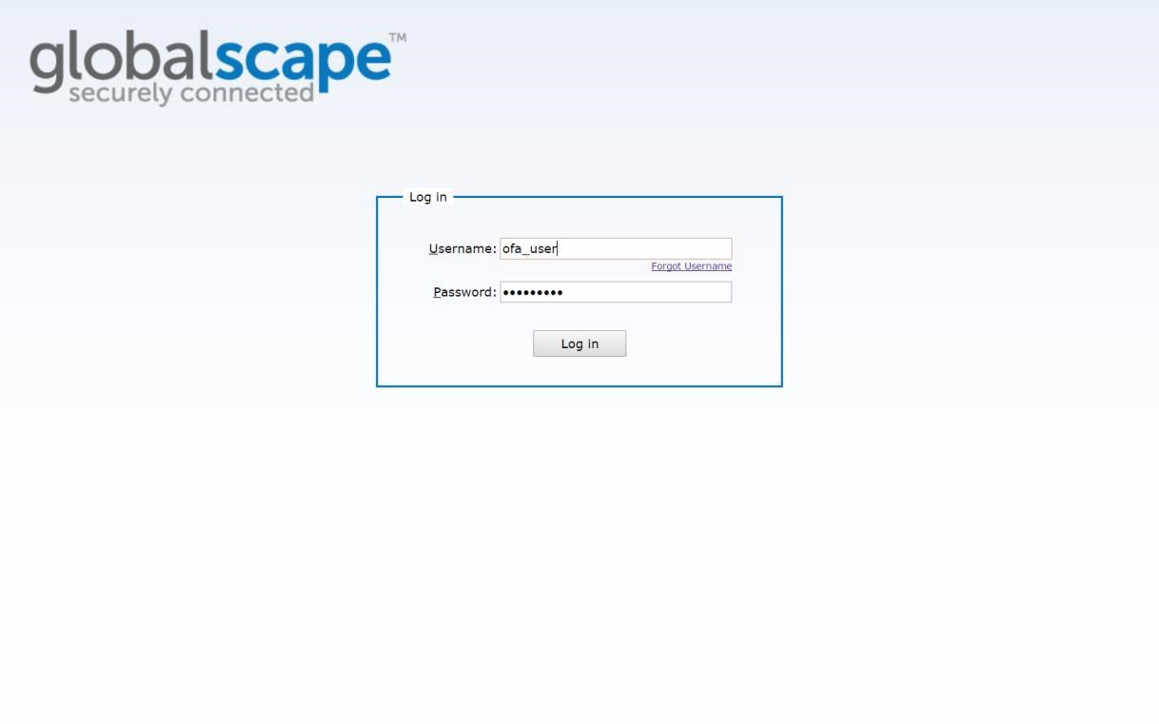
-

Enter Password

-

Click on ‘
Log in’ button

Fig 1.1

Home: The following page appears after the user logs in.

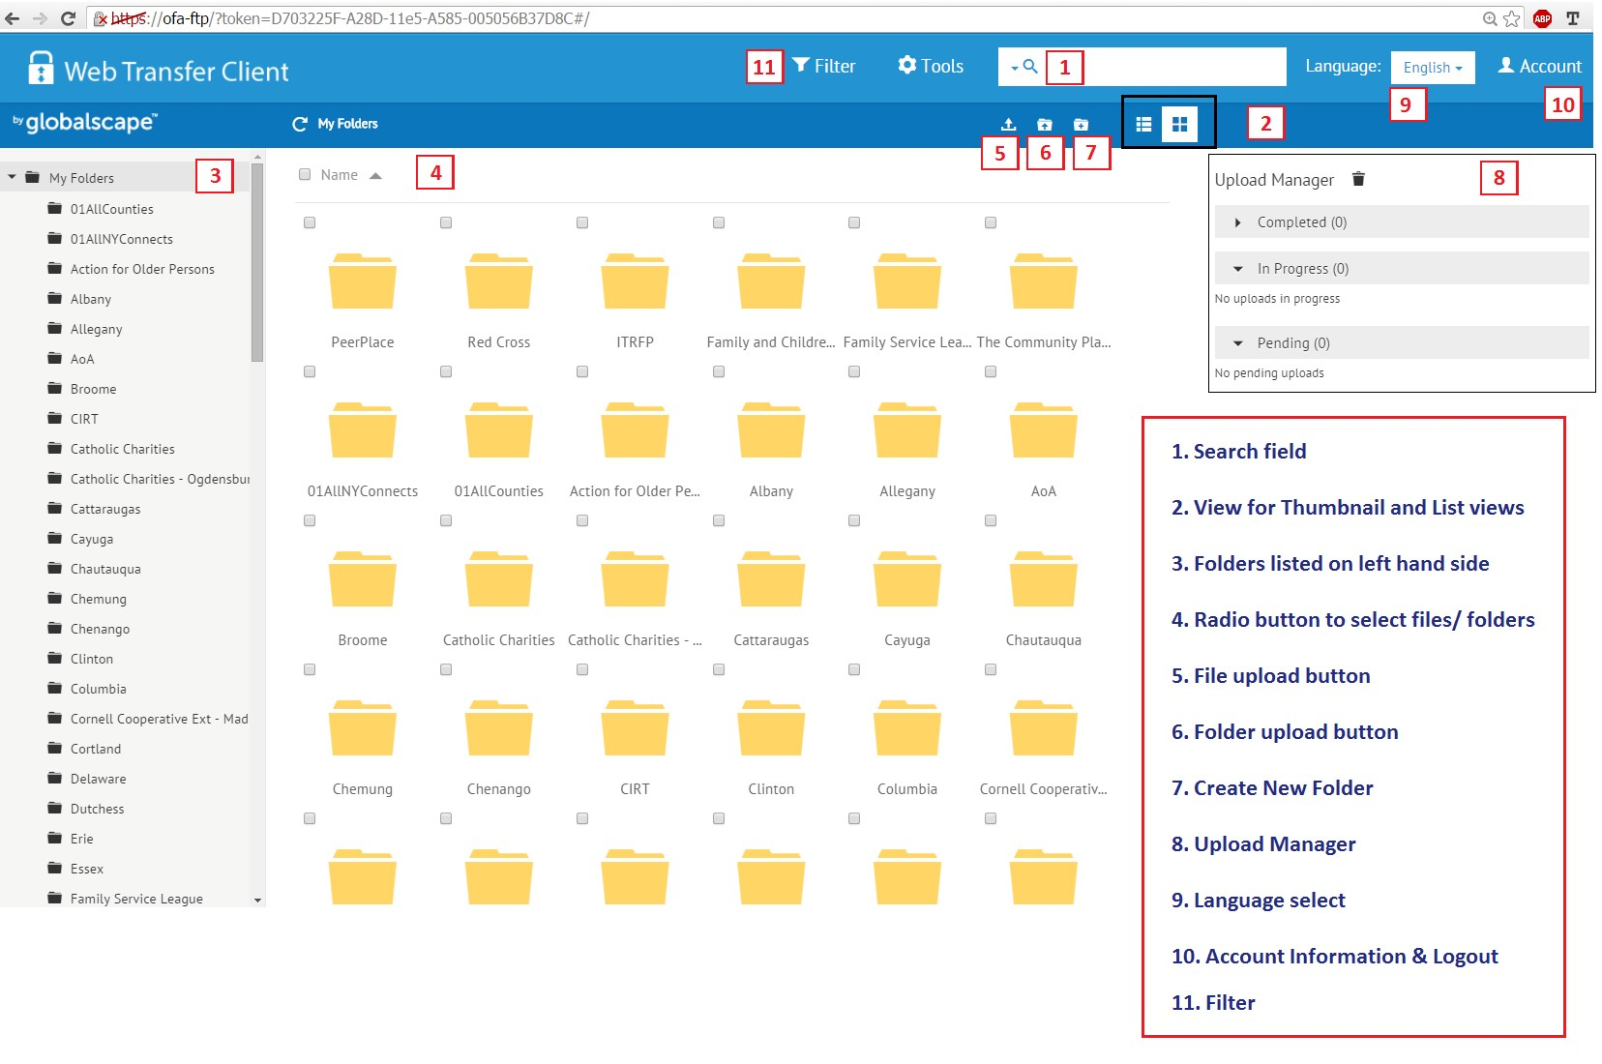

Fig 1.2

The following features are available on the home page:
- Search Field: The search field offers the option to search files, folders etc. within the given folder (path) or using the Global Search feature for a comprehensive search.

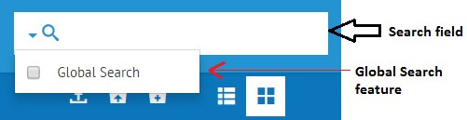

- View: Thumbnail and Grid view are available as shown in the fig. Grid view gives details about the size and date.
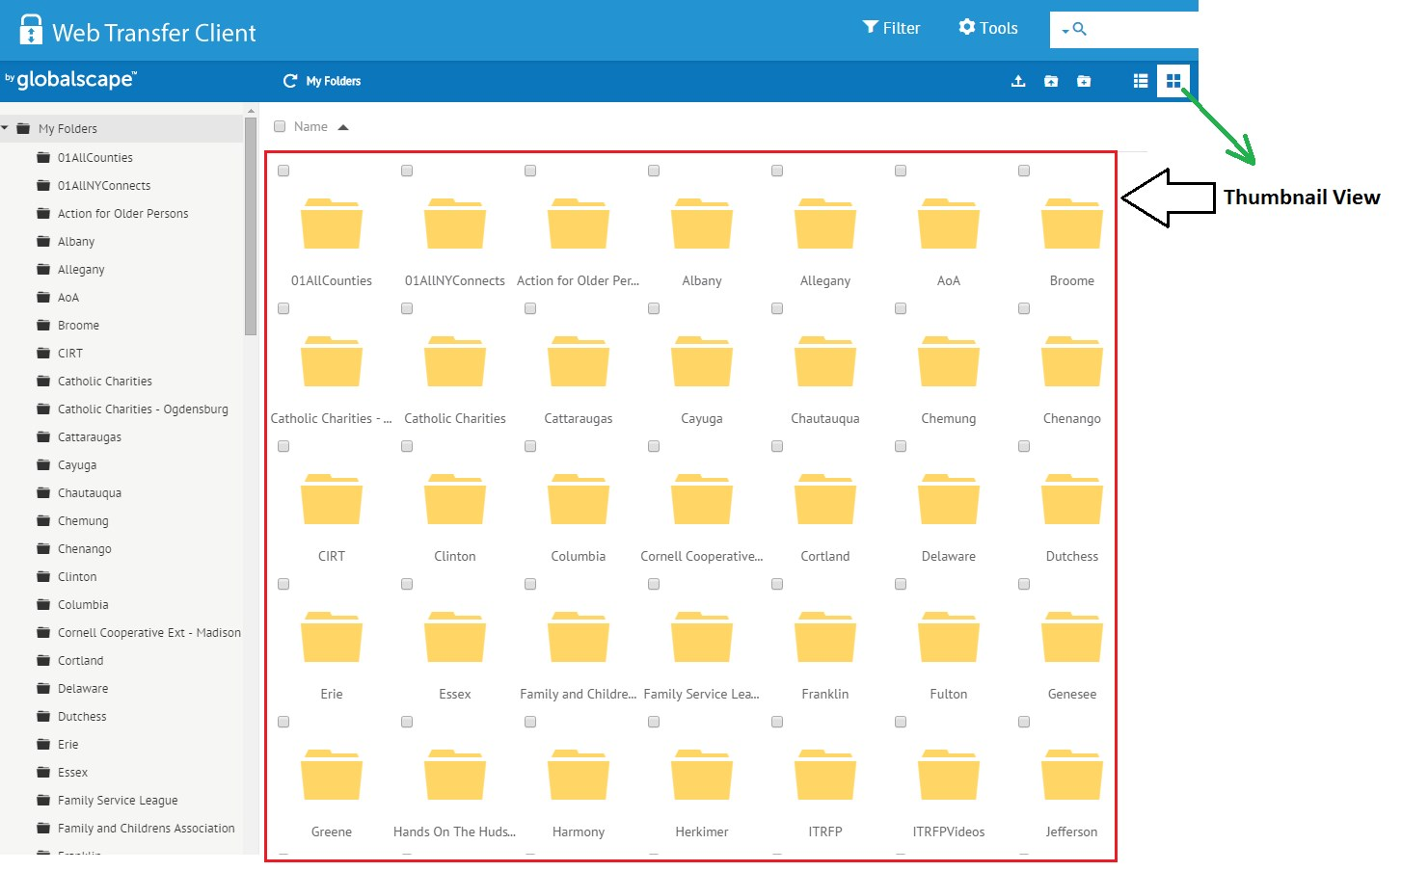

- Navigation Pane on Left hand side: Allows the user to browse through different folders.
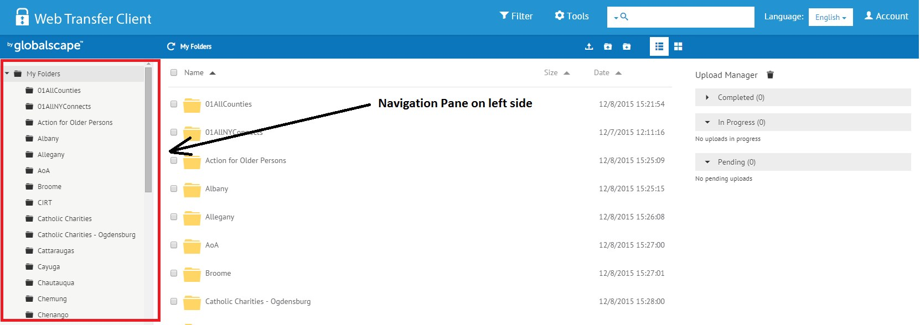

- Radio Button to select files/ folders for doing operations like delete or rename (Refer to 4 in fig 1. 2)

- File & Folder Upload: To upload files and folders to the FTP Server (Refer to 5 &6 in fig 1. 2)

- Create New Folder: (Refer to 7 in fig 1. 2)

- Upload Manager (with Delete): This is located on the right hand side of the page and lists the files uploaded. Also, features a delete button to clear the transfers listed (1 in fig). Have the following classifications (a, b, c in fig) :
  - Completed
  - In Progress
  - Pending

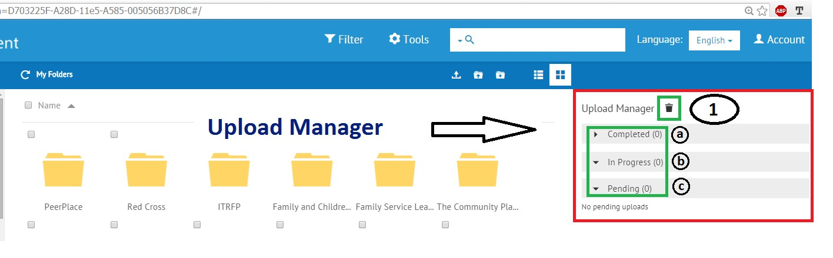

- Language Select: Users can select from the following languages English, Nederland and Deutsche
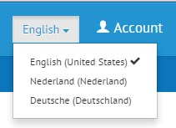

- Filter: Click on the filter icon to see the filter pop-up. The following filter options are available to filter search results:
  - By Name with the option to match case
  - By Size (>, < in Kb)
  - By Date (After, Before)
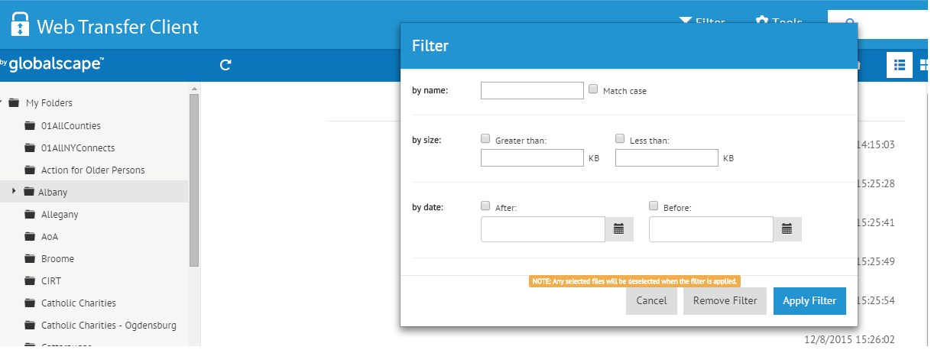

- Tools:
    - About - Gives the version and build of the software
    - Help – Help topics
    - Log – Server Web Interface Log
    - Log Options – Different log options (Presently using INFO)
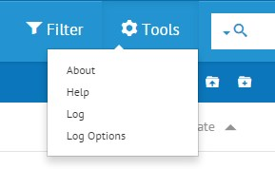

- Account: Clicking the account button (towards the right hand side) shows a drop down as shown in the fig having the options to reset password or logout of the account.
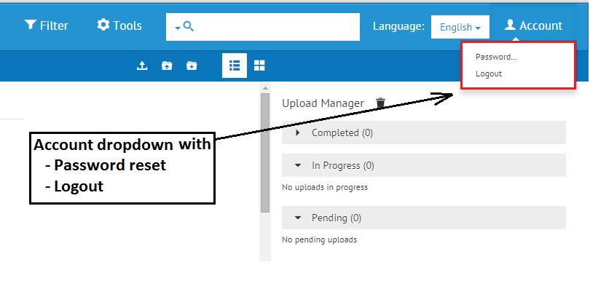

FAQS (Frequently Asked Questions)

- How to upload files?
File upload feature helps the user to upload the desired file. Follow the steps as given below:
- Click on the file upload icon
- This opens a new window
- Navigate to the desired location, select the file and click on ‘Open’
- The new file will be listed in the folder

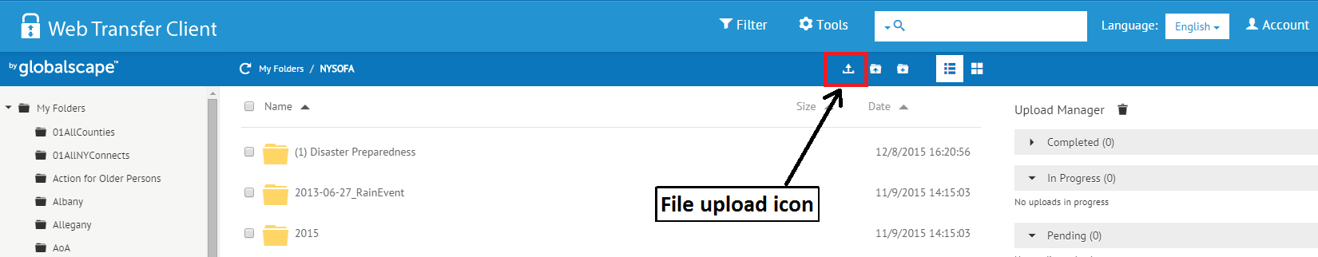
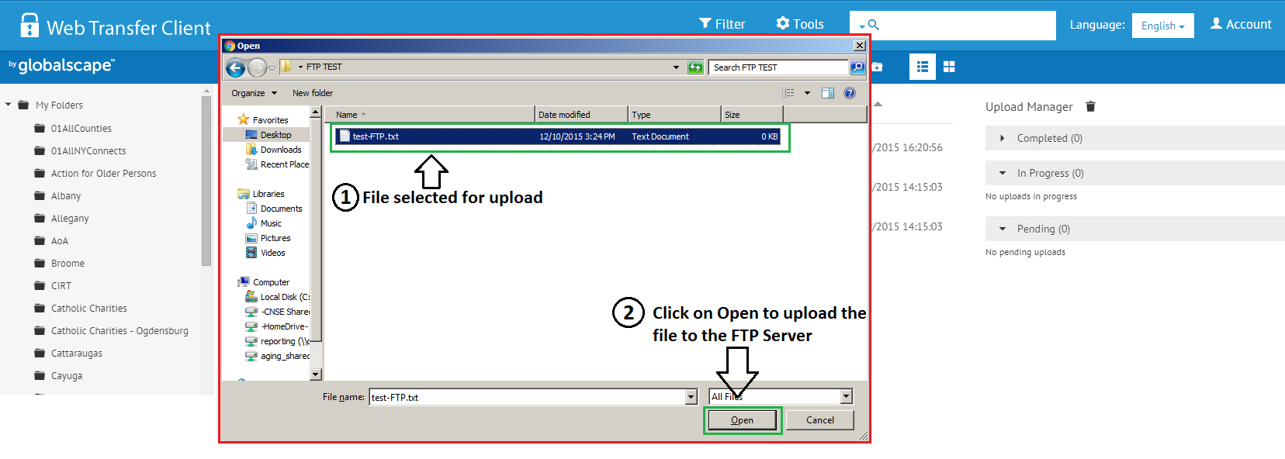
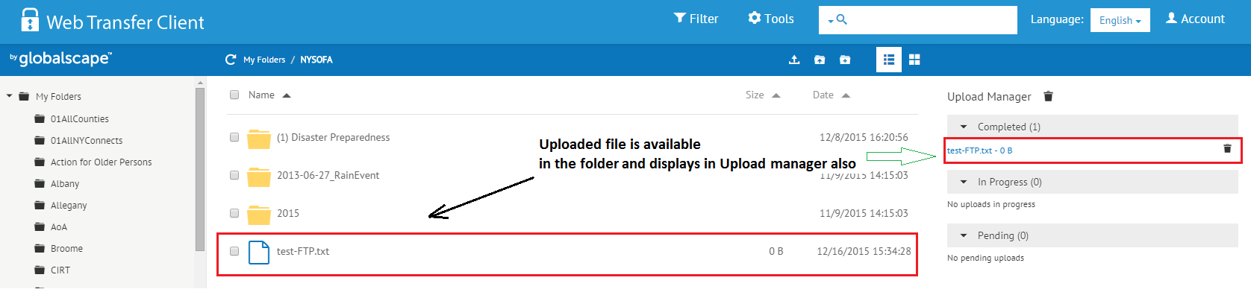

- How to upload a Folder?
This feature is available only in Chrome. Not available in Firefox & Internet Explorer.

